Smaller authority name:
NOTICE OF PUBLIC RIGHTS AND PUBLICATION
OF ANNUAL GOVERNANCE & ACCOUNTABILITY
The Accounts and Audit Coronavirus | Amendment Re ulations 2020 |  | SI 2020/404
NOTICE |  | NOTES
- Date of  - Each year the smaller authority prepares an Annual Governance and Accountability Return (AGAR). The AGAR has been published with this notice. it will not be reviewed by the appointed auditor, since the smaller authority has certified itself as exempt from the appointed auditor's review.  Any person interested has the right to inspect and make copies of the AGAR, the accounting records for the financial year to which it relates and all books, deeds, contracts, bills, vouchers, receipts and other documents relating to those records must be made available for inspection by any petson interested. For the year ended 31 March 2020, these documents will be available on reasonable notice by application to:  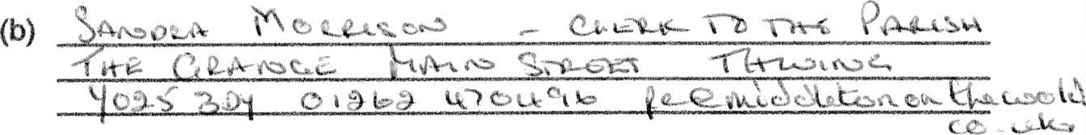  commencing on (c) _Monday 15 June 2020  and ending on (d) Friday 24 July 2020  - Local govemment electors and their representatives also have:  The opportunity to question the appointed auditor about the accounting records; and  The right to make an objection which concerns a matter in respect of which the appointed auditor could either make a public interest report or apply to the court for a declaration that an item of account is unlawful. Written notice of an objection must first be given to the auditor and a copy sent to the smaller authority.  The appointed auditor can be contacted at the address in paragraph 4 below for this purpose between the above dates only.  - The smaller authority's AGAR is oniy subject to review by the appointed auditor if questions or objections raised under the Local Audit and Accountability Act 2014 lead to the involvement of the auditor. The appointed auditor is:  PKF Littlejohn LLP (Ref: SBA Team)  15 Westferry Circus  Canary Wharf  London E14 4HD  (sba@pkf-litt'ejohn.com)  - This announcement is made by 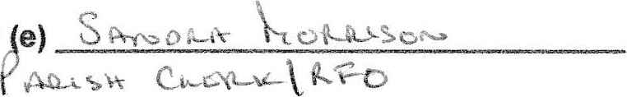e) |  | - Insert date of placing of the noti( which must be not less than 1 day befo the date in (c) below  - Insert name, position a! address/telephone number/ em address, as appropriate, of the Clerk  •other person to which any person m apply to inspect the accounts  - Insert date, which must be at least day after the date of announcement in ( above and at least 30 working da before the date appointed in (d) below  - The inspection period between and (d) must be 30 working da inclusive and must start on or before September 2020.  - Insert name and position of persc placing the notice this person must i the responsible financiai officer for ti smaller authori
RETURN (EXEMPT AUTHORITY)
ACCOUNTS FOR THE YEAR ENDED 31 MARCH 2020
Local Audit and Accountability Act 2014 Sections 25, 26 and 27
The Accounts and Audit Regulations 2015 (SI 2015/234)

